Minot Park Foundation Meeting
December 17, 2024

The Minot Park Foundation Board meeting began immediately following the Minot Park Board Meeting. Members present: Perry Olson, Chelsea Kirkhammer, Justin Hammer and Mike Schmitt. Elly DesLauriers was also present.
Motion by Hammer, second by Kirkhammer to approve the minutes from the November 19 foundation meeting. Motion carried.
Motion by Hammer, second by Kirkhammer to approve the total bills of $144,167.80.
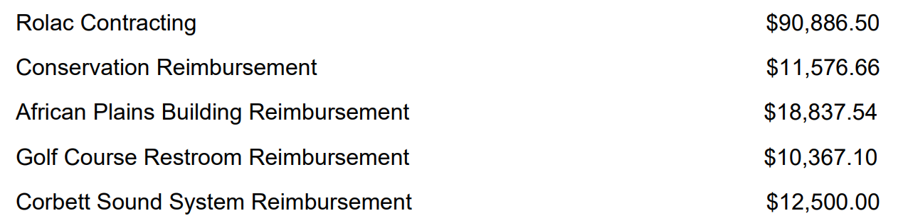
On roll call, all members voted yes.
Motion by Kirkhammer, second by Hovda to adjourn the meeting. Motion carried.

Perry Olson, President Elly DesLauriers, acting Clerk

